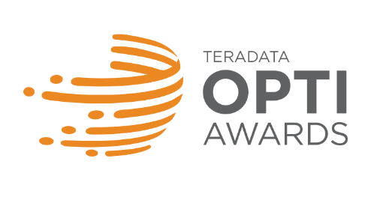
Sample Entry Form Deadline June 15, 2018

Nominated Customer Contact:
Company Name:
Primary Contact Name:
Primary Contact Job Title:
Primary Contact Email:
Primary Contact Phone:
Primary Contact Country: Sample Entry Form

If this is being submitted by someone else on behalf of a Teradata customer, please complete this section:
Submitter Company:
Submitter Name:
Submitter Job Title:
Submitter Email:
Submitter Phone:
Submitter Country:

What is the Project Name?
Please select a category. Visit www.teradata.com/opti-awards for category descriptions.
Amazing Analytics
Cloud Revolution
Relationship Voyager
Return on Innovation

Who is the Executive Sponsor of this project?
Sponsor Name:
Sponsor Title:
Sponsor Email:
This is not a requirement, but if your company is designated as a "winner," would this person or another executive consider speaking at this year’s conference on Oct. 14-18, 2018 in Las Vegas?

- What is the mission/vision of the customer company and which strategic goals does this project support?
- What was the business purpose of your project? What challenges were you trying to solve? What were your goals?
- Give us an overview of your project. What was the solution you created? How was it implemented? No need to include results here, we will get to that question later.
- What is innovative about your project? What are you doing differently than what you’ve done before? Are you using a new technology or using existing technology in a new way? What can you do now that you couldn’t do before this project?
- What are the business results generated by your project? You may include details on the hard and soft benefits realized including impact on business decisions or insights and/or include measurable business benefits with evidence and data (e.g. detailed ROI for financial values, increased market share, number of new customers gained, etc.)
- Do you foresee any additional benefits in the future? Or do you have plans to extend the project, make changes or additions in the future?
- Provide an executive summary of the project to be used in a Teradata Press Release should your initiative be awarded. Please include a project overview, why it is innovative and one major KPI that can be shared publicly.
** Optional: If you are a customer, is there a specific alliance partner you wish to recognize that was important to the success of this project?
Partner Company Name:
Partner Contact Name:
Partner Contact Job Title:
Partner Contact Email:
Partner Contact Phone:
Partner Contact Country:

** Optional: Supporting Materials: Please provide us with any supporting material (pdf document, slide, diagram, etc.) that you believe will help judges evaluate your nomination.

By submitting this nomination, I acknowledge that the information it contains is accurate and that the appropriate parties at the nominated organization(s) are aware of and approve this nomination, its contents and agree to be publicly recognized if a winner or finalist.

Entries accepted at www.teradata.com/opti-awards beginning April 20, 2018.

